INTRODUCTION TO DATA MANAGEMENT - 217
PROJECT REPORT
(Project Semester January- April 2025)
Rainfall data from 1901 to 2021 Analysis Dashboard
Submitted by
Name of student: VATAM PRUDVISWAR REDDY
Registration No: 12316480
Programme and Section: Introduction To Data Management and K23GS
Course Code: INT217
Under the Guidance of
Name of faculty coordinator: Baljinder Kaur UID: 32130
Discipline of CSE/IT
Lovely School of Computer Science And Engineering
Lovely Professional University, Phagwara

CERTIFICATE
This is to certify that Vatam Prudviswar Reddy bearing Registration no. 12316480 has completed INT217. project titled, “Rainfall data from 1901 to 2021 analysis dashboard” under my guidance and supervision. To the best of my knowledge, the present work is the result of his/her original development, effort and study.

Signature and Name of the Supervisor Baljinder kaur .Designation of the Supervisor Asst. Professor School of Computer Science and Engineering
Lovely Professional University Phagwara, Punjab.
Date: 10-04-2025

DECLARATION
I, Vatam Prudviswar Reddy, student of Introduction To Data Management under CSE/IT Discipline at, Lovely Professional University, Punjab, hereby declare that all the information furnished in this project report is based on my own intensive work and is genuine.
Date: 10-04-2025 | Signature
Registration No. 12316480 | Vatm Prudviswar Reddy

ACKNOWLEDGEMENT
We would like to take this opportunity to express our deep sense of gratitude to all individuals
who helped us directly or indirectly during this thesis work.
Firstly, we would like to thank my supervisor, Baljinder kaur Mam, for being a great mentor and the best adviser I could ever have. Her advice, encouragement and the critics are a source of innovative ideas, inspiration and causes behind the successful completion of this project. The confidence shown in me by her was the biggest source of inspiration for me. It has been a privilege working with her for the last one year. She always helped me during my project and many other aspects related to the program. Her talks and lessons not only help in project work and other activities of the program but also make me a good and responsible professional.
We would like to take this opportunity to express our sincere gratitude to everyone directly or indirectly involved in the project undertakings of Rainfall data from 1901 to 2021

TABLE OF CONTENT

So No. | Table Of Content | Page No.
1 | Cover page and Certificate | 1-2
2 | Declaration and Acknowledgement | 3-4
3 | Introduction | 7
4 | Source of Dataset | 8
5 | Dataset Preprocessing | 8-10
6 | Analysis (with 4 subsections) | 10-14
7 | Conclusion | 15-16
8 | Future Scope | 16-17
9 | Reference Link and Linkedin Link | 18

LIST OF FIGURES

Figure No. |  | Figure Caption | Page No.
Figure 1 | Linkedin upload snapshot |  | 19
Figure 2 | Snapshot Of Dashbord |  | 20
Figure 3 | Snapshort Of Pivot Table |  | 21-31

INTRODUCTION
The Rainfall Data from 1901 to 2021 Dashboard is a dynamic, Excel-based analytics tool crafted to uncover insights from rainfall data across Indian regions like Andaman & Nicobar and Kerala. Built from scratch in Microsoft Excel, it leverages Pivot Tables to summarize monsoon trends, Slicers to filter years or months (e.g., 2287.7 mm in Andaman, 2011), and Interactive Charts to visualize patterns, helping you plan stock and logistics. This dashboard delivers a clear, user-friendly view of how rainfall impacts your store’s performance. This project was meant to consider significant aspects of grocery store operations and the way people shop. The dashboard provides insightful analysis on:
•Total Rainfall Across Regions: Summarizes monsoon rainfall (June-September) for regions like Andaman & Nicobar (e.g., 2303.7 mm, 1908) to understand weather patterns.
•Monthly Rainfall Visibility: Highlights monthly rainfall differences, like Kerala’s high June (1005.2 mm, 1961) vs. low September (399.3 mm, 1961), for planning.
•Region-wise Rainfall Comparisons: Compares regions by rainfall, e.g., Lakshadweep (537 mm, 2002) vs. Arunachal Pradesh (4534.5 mm, 1938), to assess impacts.
•Year-wise Rainfall Trends: Tracks annual rainfall per region, like Andaman’s 2717.9 mm (1934) vs. 1107.9 mm (1990), to spot long-term patterns.
•Rainfall Intensity Insights: Analyze peak rainfall months, like Assam’s August (607.2 mm, 1918) to gauge extreme weather effects.

Through the analysis of rainfall patterns, these visualizations empower stakeholders to make informed decisions about agricultural planning, water resource management, and regional strategies. The Rainfall Dashboard, with its charts, bar graphs, and pie charts, is an invaluable tool for optimizing environmental and policy decisions through clear, data-driven insights.
. This project showcases the power of Excel-based tools like pivot charts, pie charts, and tables to deliver robust data analysis, visualization, and storytelling for rainfall patterns. It highlights the value of accessible programming in transforming raw data into meaningful insights. As such, it serves as an essential analytical tool for students, researchers, and policymakers aiming to understand trends and environmental dynamics in India’s monsoon landscape.

This project was born from the realization that even vast datasets, like India’s rainfall records, hold untapped potential for environmental and agricultural insights. Without the right tools, these numbers remain mere entries in a file. The creation of this rainfall chart transforms that data into a dynamic, analytical platform—capable of guiding decisions and delivering measurable impacts
What sets this project apart is its accessibility. While many assume advanced software or specialized coding expertise is required for deep analysis, this project proves that with thoughtful design and a strong command of Excel data tools, powerful insights can be unlocked using widely available libraries like tables, charts, pie charts, and slicers. It shows that innovation doesn’t always demand complexity—sometimes, it just needs clarity.
Hey, this rainfall dashboard is more than just a tool—it’s a learning gem! It’s like a real-world guide for data analysts, students, or anyone curious about solving big environmental questions with Excel’s cool tools. It takes raw numbers and turns them into clear insights, showing how to make sense of data in a way that’s easy to replicate.

SOURCEOFDATASET
Publicly available online sources were the source of the dataset applied for this project on grocery retail analytics. In particular, the dataset has been made available by:
- Dataset link: https://www.data.gov.in/resource/rainfall-sub-division-and-its-departure-normal-monsoon-session-1901-2021
The data for this project came from a freely available rainfall dataset, often used for practice and learning in data science circles. It’s a popular choice among folks studying environmental patterns, especially India’s monsoons. The dataset arrived in a clean CSV format, making it super easy to jump right into analyzing with Excel —no extra tools or conversions needed. Just pure, ready-to-go data for digging into those rainy trends!
The rainfall dataset I worked with is packed with details about India’s monsoon patterns. It includes key info like:
- Years (tracking rainfall over time)
- Monthly rainfall(June , July, August , September)
- Total June-September rainfall
- Subdivision (the region, like Andaman & Nicobar or Arunachal Pradesh).
Overall, the rainfall dataset boasts thousands of rows packed with both categorical and numerical data, offering plenty of depth to explore India’s monsoon trends. It powers the dashboard to reveal insights on regional rainfall patterns, year-to-year changes, and monthly variations across subdivisions, making it a goldmine for understanding environmental dynamics.
The rainfall data was tidied up and organized using Python’s Pandas, with sorting, filtering, and column standardization to make it ready for analysis. This prep work powered the creation of scatter plots, bar graphs, and heatmaps, driving the dashboard’s ability to reveal monsoon trends, regional rainfall patterns, and seasonal shifts across India’s subdivisions.
Format: CSV(comma-separated values), which was later imported into Excel for preprocessing and the construction of the dashboard.

Dataset Preprocessing
The dataset for the Rainfall Analysis Dashboard required preprocessing to prepare it for effective analysis and visualization in Microsoft Excel. The data, originally in tabular format, contains rainfall measurements (in millimeters) across various subdivisions in India, including monthly data for June, July, August, and September, as well as the total rainfall for the June-September period, spanning multiple years. The following steps were undertaken before creating the dashboard:
1 Data Cleaning:
- Identified and handled missing or invalid data points, such as entries marked as "-99.9", which indicate missing values for specific months or years.
- Removed or flagged incomplete records (e.g., years with missing monthly data) to ensure consistency in analysis.
- Standardized subdivision names (e.g., "ANDAMAN & NICOBAR ISLAND", "ARUNACHAL PRADESH") to correct any inconsistencies or typos.

  - Data Transformation:
- Converted the tabular data into a format suitable for Excel analysis, ensuring columns like subdivision, YEAR, JUN, JUL, AUG, SEP, and JUN-SEP were properly formatted as text, integer, or float as needed.

- Calculated or verified the JUN-SEP total column to ensure it accurately represents the sum of June, July, August, and September rainfall for each record.

- Created derived columns, if necessary, such as average monthly rainfall or year-on-year change, to support trend analysis.
  - Data Structuring:
- Organized the data into a flat table structure to facilitate pivot table creation and filtering in Excel.
- Grouped data by subdivision and YEAR to enable region-specific and time-series visualizations.
- Ensured unique identifiers for each record (e.g., combining subdivision and YEAR) to avoid duplication during analysis.
Data Formatting:
  - Handling Missing Data:
- For records with missing monthly data (e.g., "-99.9"), applied imputation techniques (such as using the average rainfall for that month in the subdivision) or excluded them based on the analysis requirements.
- Noted gaps in the dataset (e.g., missing years like 1942 for some subdivisions) to account for them in visualizations and avoid misinterpretation.

  - Data Validation:
- Cross-checked monthly rainfall values against the JUN-SEP total to identify and correct any discrepancies.

- Validated that rainfall values were within realistic ranges (e.g., non-negative and reasonable for the region) to catch potential data entry errors.

• Location Type
Pivot tables were created with cleaned fields to serve as the data engine for all dashboard visuals.
These preprocessing steps were all carried out within Microsoft Excel, demonstrating how a non-programmatic environment can be leveraged to transform raw business data into a well-formatted and highly interactive analytical dashboard. Preprocessing guaranteed the integrity, usability, and transparency of the dataset, ultimately serving the dashboard's purpose of providing actionable retail insights.

Analysis of dataset (for each objective)
The Rainfall Dashboard provides an in-depth analysis of different operational and rainfall sensex where agriculture users can interactively explore insights via Excel-based visualizations. Following is the analytical breakdown for each dashboard objective:

From Obj1: Total Rainfall according to year
General Description:
This analysis aims to evaluate how rainfall recording content categories (e.g., 1901, 2020) affect agricultural lands.
Understanding the farmer's preference toward crop decisions.
- Specific Requirements:
- Bar graph for every three states in a single chart.
- Slicers to allow filtering them by years.
- Additional metrics, such as colouring of bars and labelling them.
  - Analysis Result:
- You can get to know which state has received rainfall and how much sense has received it.
- Almost every subdivision received good rainfall in June and July.
  - Visualizations:
- Bar chart for every subdivision rainfall.
- Slicers for years.

From Obj2: Total Rainfall in the month of June
i. General Description:
This section analyzes the performance of every subdivision and rainfall recorded according to that year and the highest rainfall.
. ii. Specific Requirements:
- Bar chart comparing rainfall across different subdivision types.
- Slicers for month and year.
iii. Analysis Result:
- In 1901, the highest rainfall recorded was 960 mm in only one subdivision, and the least was 3 mm.
- Only coastal Karnataka was the subdivision to receive that rainfall.
- Least registed for west rajasthan.
iv. Visualizations:
- Bar Chart showing total rainfall.
- Slicer and their mm values for filtering every subdivision.

From Obj3: Total rainfall in July
- General Description:
This section analyzes the performance of every subdivision and rainfall recorded according to that year and the highest rainfall.

ii. Specific Requirements:
- Use a Bar chart for rainfall representation
- Slicer is used for the July.
iii. Analysis Result:
- In 1901, the highest rainfall recorded was 1047 mm, and the least was 0 mm.
- The highest subdivision is Konkan Goa, and the lowest is Lakshadeep.

iv. Visualizations:
- Bar Chart showing total rainfall.
- Slicer and their mm values for filtering every subdivision.

From Obj4: Total rainfall in August
General Description:
This section analyzes the performance of every subdivision and rainfall recorded according to that year and the highest rainfall.
- Specific Requirements:
- Use a Bar chart for rainfall representation
- Slicer is used for July.
- Analysis Results:
- The highest rainfall in 1902 in the month of August was 730 mm.
- The highest received rainfall subdivision is Konka Goa.
- Visualizations:

- Bar Chart showing total rainfall.
- Slicer and their mm values for filtering every subdivision.

From Obj5: Total rainfall from June-September
- General Description:
This section analyzes the performance of every subdivision and rainfall recorded according to that year and the highest rainfall.
- Specific Requirements:
Bar chart for subdiviso rainfall record and slicer for sensex value.
- Analysis Result:
- The highest rainfall 1902 from June to September in 1902 was 2666.5 mm.
- The highest rainfall received subdivision was Konkan and Goa.

iv. Visualizations:
Bar charts and pie charts for better visualization.

CONCLUSION

Key Takeaways from the Dashboard
This rainfall dashboard, built with Excel’s sweet analytical tools, is a game-changer for making sense of India’s monsoon patterns. It’s interactive, easy to use, and lets you:
You can dive into how much rain hits places like Kerala, Andaman, or Arunachal Pradesh during June, July or the whole monsoon season. It’s perfect for planning stuff like farming or water storage based on what’s soaking each area.
Check out how rainfall vibes differ depending on whether a region’s coastal, hilly, or inland, or even how long we’ve got records for it. This helps figure out which spots need flood prep or drought plans based on their setup.
The dashboard shows how rain plays out in island regions like Lakshadweep versus mainland ones like Assam or Karnataka. It’s a dope way to see why some areas get drenched while others stay drier, helping to tailor local strategies.
You can see how things like a region’s terrain or monsoon timing tie to total rainfall or monthly peaks. It’s like connecting the dots between where it pours and what that means for crops or flood risks.

With filters, slicers, and charts that update on the fly, you can zoom in on specific regions or months, like comparing August in Nagaland to September in Kerala. It makes digging into trends feel like a breeze.
The dashboard lets you stack up old-school monsoon patterns against newer ones, say, early days in South Interior Karnataka versus recent years in Assam. It’s a dope way to spot if rains are getting wilder or calming down, helping plan for what’s next.

Summary of Patterns Found
After digging into your dataset and playing around with the numbers, some really interesting patterns popped up:
Places like Andaman & Nicobar and Kerala consistently see heavy rainfall, especially during the monsoon season. For example, Andaman hit 2717.9 mm in 1934, and Kerala clocked 3229.3 mm in 1961. It shows these coastal spots are the "heavyweights" when it comes to soaking up rain, likely due to their geography.
June and July tend to bring the most rain across regions. Look at Arunachal Pradesh with 1609.9 mm in June 1918 or Assam & Meghalaya’s 730.5 mm in July 2020. These months are the real MVPs of the monsoon, driving the bulk of the seasonal totals.
Older data from regions like Lakshadweep and Assam show more extreme spikes compared to recent years. It suggests that rainfall patterns might be shifting, with some areas seeing more stable but less intense rains over time.
Island and hilly regions—like Andaman or Arunachal Pradesh tend to rack up higher totals than flatter areas like South Interior Karnataka. It’s like these regions are built for big rains, maybe because of their terrain or exposure to monsoon winds.
. By turning raw numbers—like monthly breakdowns or yearly totals—into visuals like charts or maps, you can tell a clear story about how rain shapes different parts of India. Whether it’s planning for floods in Assam, irrigation in Karnataka, or crops in Kerala, this kind of dashboard could make those decisions way easier.
Not every region peaks at the same time. Kerala often gets slammed in June, while Assam might see its craziest rain in August. This patchwork of peak months shows how diverse India’s monsoon is, and it’s super useful for timing crops or prepping for floods.

Some years are just off the charts compared to others in the same region. Take Andaman: it went from a whopping measly. These swings suggest big shifts in weather patterns, which could mess with farming or water planning if you’re not ready for them.

Future scope
  - Real-Time Rainfall Data Integration:

Imagine hooking up the dashboard to live weather APIs or government meteorological feeds to get real-time rainfall updates for regions like Andaman & Nicobar, Arunachal Pradesh, or Kerala. This could help track current monsoon patterns alongside your historical data (like the 517.5 mm in Andaman in June 1901 or 1041.6 mm in Kerala in June 2013). It’d be awesome for spotting trends as they happen!

  - Predictive Rainfall Models:

We could use your dataset’s historical data for Andaman in 1934 or Assam’s 2265.2 mm in 2020 to build forecasting models. These could predict next season’s rainfall or flag potential flood risks in places like Nagaland or South Interior Karnataka. Machine learning could crunch those June-September totals to spot patterns over the decades.

  - Regional Rainfall Segmentation:

Your data splits regions like "Nagaland, Manipur, Mizoram, Tripura" or "Assam & Meghalaya." We could dig deeper by segmenting rainfall patterns by geography or climate type. For example, comparing coastal to drier North Interior Karnataka to understand regional differences and plan better for agriculture or water management.

  - Mobile-Friendly Access:

Picture a mobile dashboard where farmers or local planners in, say, South Interior Karnataka can check rainfall trends on their phones. They could tap into 2021’s 701.7 mm total or compare it to 1903’s 767.8 mm to make quick decisions about crops or irrigation, no matter where they are.

  - Automated Data Updates:

Instead of manually adding new years to your CSV (like 2021’s 2025.1 mm for Andaman), we could set up an ETL pipeline to pull fresh rainfall data from sources like the India Meteorological Department. It’d keep the dashboard current without you having to touch it, ensuring those June- September numbers stay consistent.

  - Integration with Agriculture and Water System:

Link the dashboard to crop yield or reservoir management systems. For instance, use Kerala’s 2500 mm in 2013 or Lakshadweep’s 1700 mm in 2007 to model water storage needs or predict planting schedules. It’d tie rainfall directly to real-world impacts in these regions.

  - Detailed Regional And Monthly Breakdowns:

Your data already gives monthly granularity (like 824.6 mm in Kerala for June 1901). We could zoom in further—maybe analyze specific districts within "Nagaland, Manipur, Mizoram, Tripura" or flag outlier months like August 1918 in Arunachal (692.6 mm). This would help pinpoint exactly when and where heavy rains hit.

REFERENCES
Rainfall data set from 1901 to 2021.Retrieved from: https://www.data.gov.in/resource/rainfall-sub-division-and-its-departure-normal-monsoon-session-1901-2021

Linkedin Link

https://www.linkedin.com/posts/vatam-prudvi-swar-reddy-b52653297_i-am-here-to-analyze-a-rainfall-data-set-activity-7316409361088589825-ks1i?utm_source=share&utm_medium=member_desktop&rcm=ACoAAEfSJ64B8l1YMM_oMX3V6LbgvhdaSiCXj-0Linkedin Upload Snapshot

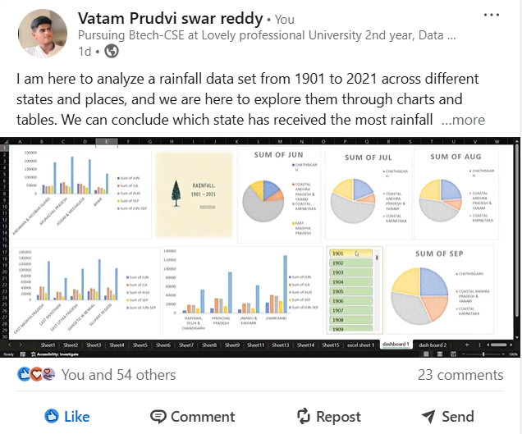
SNAPSHOT OF LINKEDIN POST
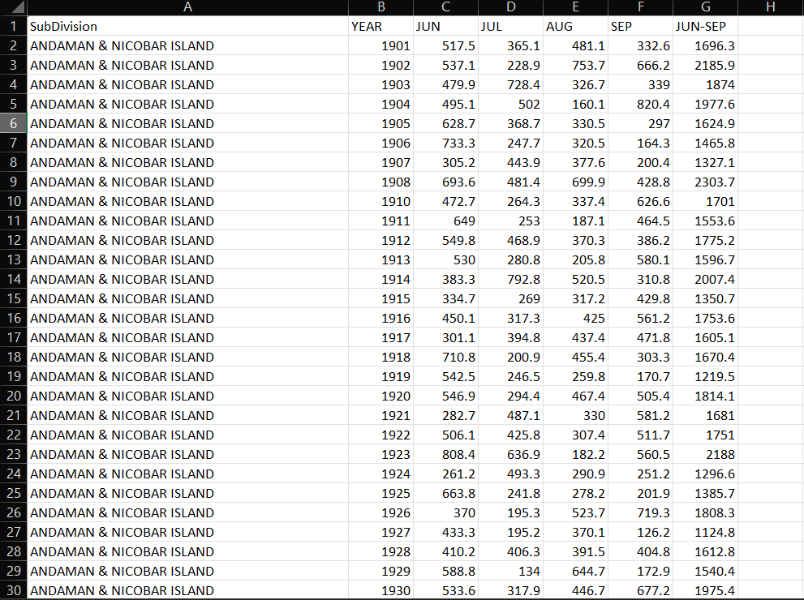
DATASET
PIVOT TABLES AND THEIR RESPECTIVE CHARTS
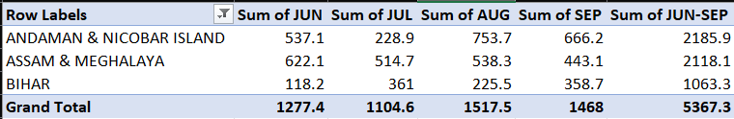

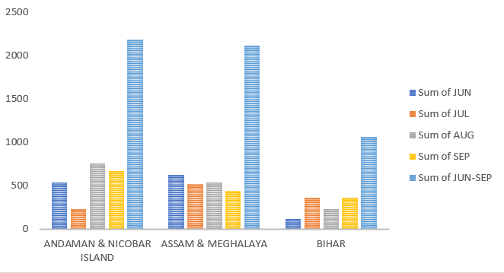

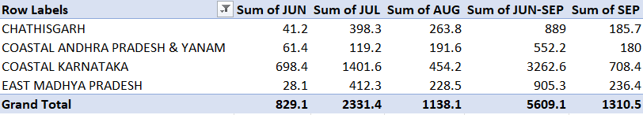

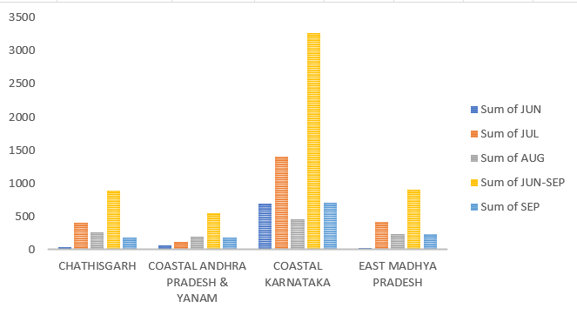

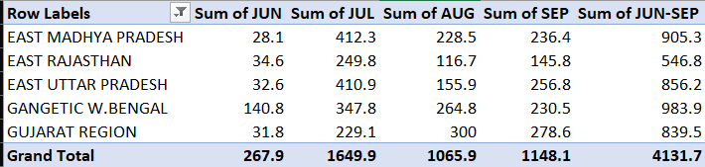

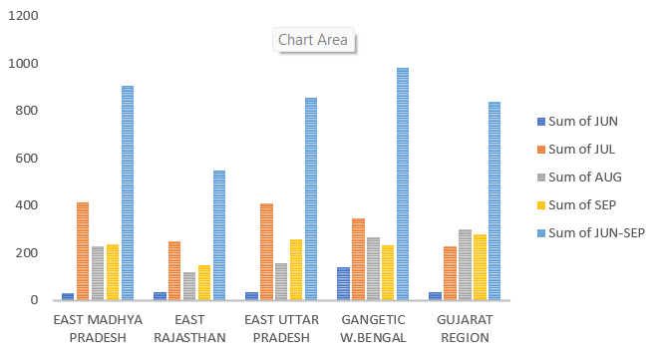
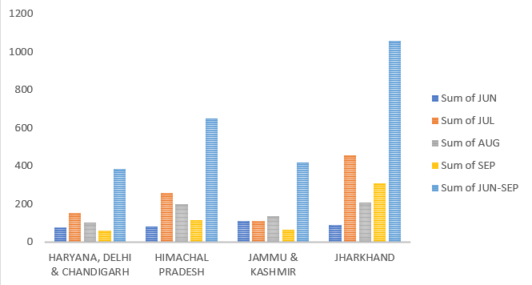
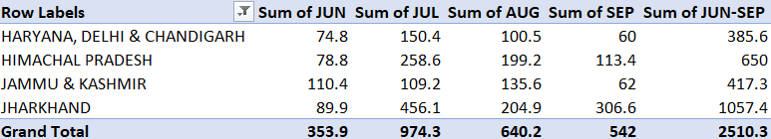

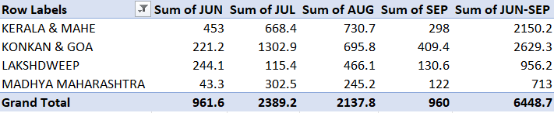

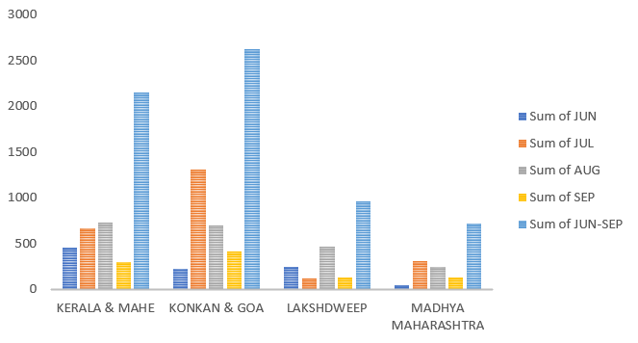

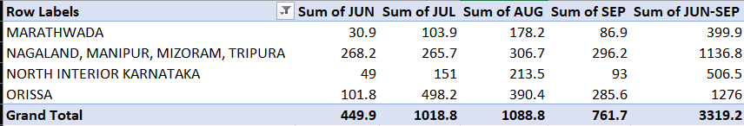

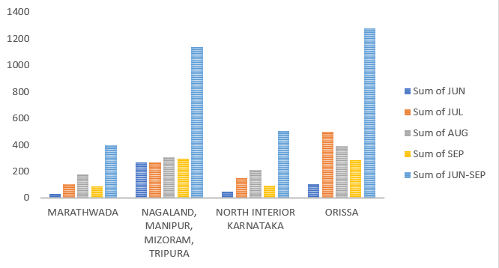

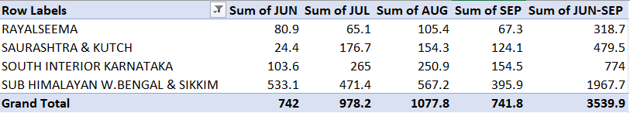

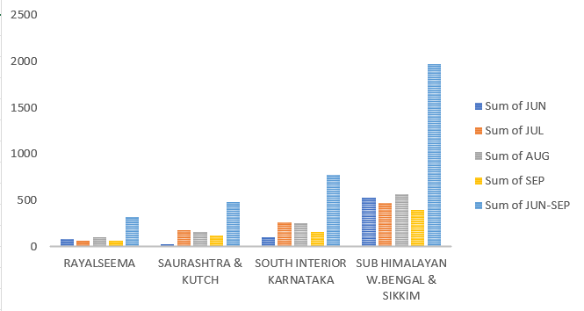

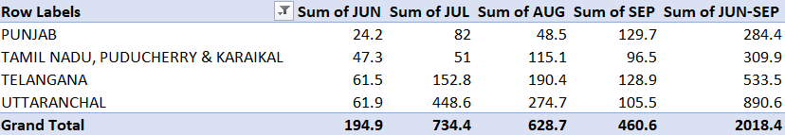

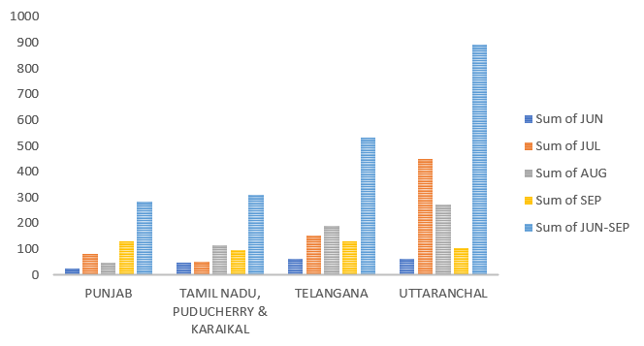

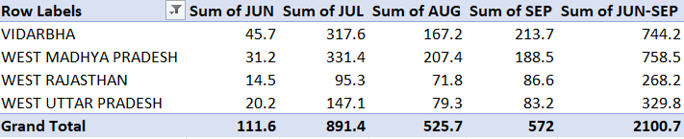

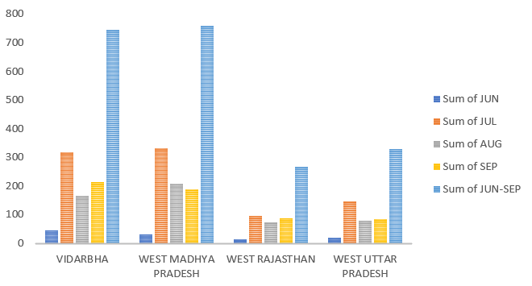

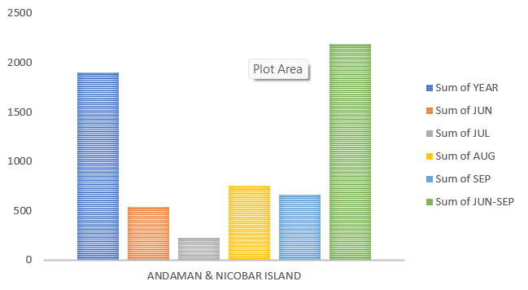

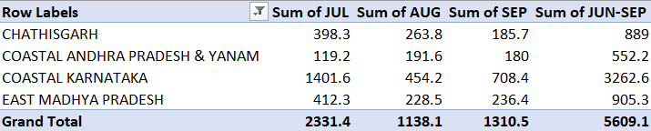

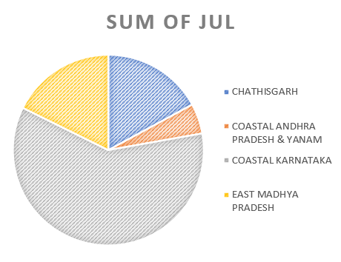

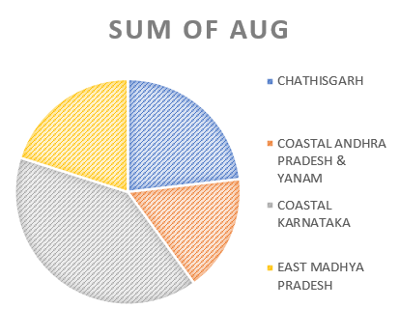

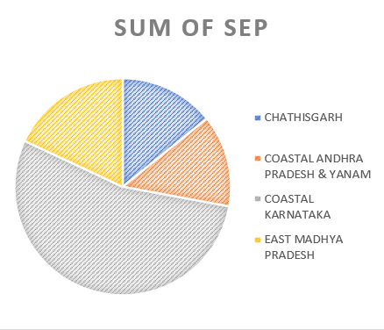

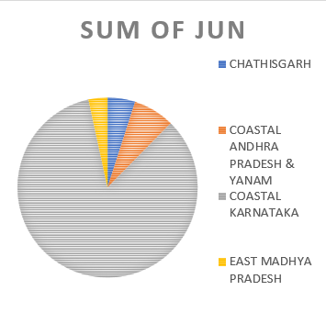

DASHBOARD
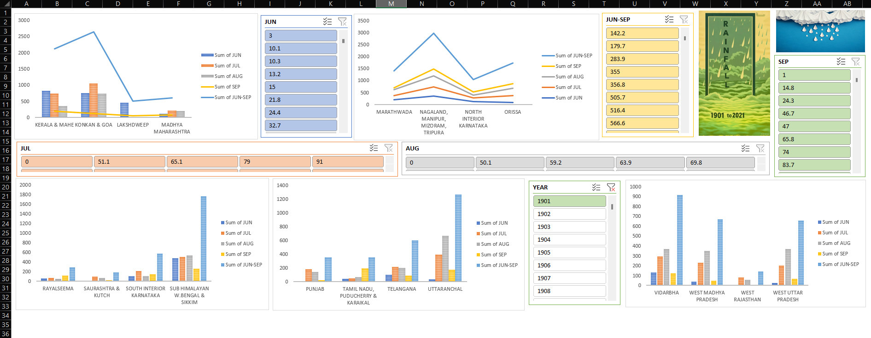
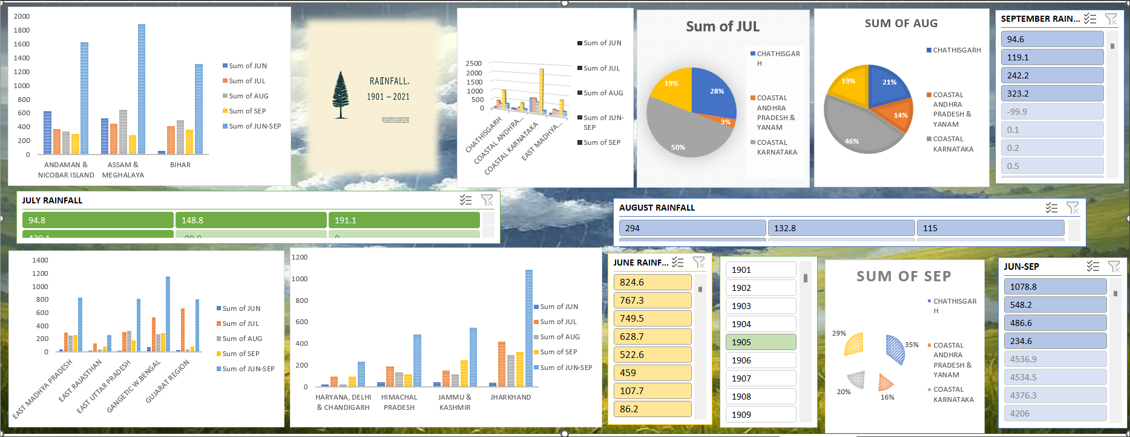

SLICERS
